# Flow Control

## Stop-And-Wait ARQ

1. Explain why a Stop-And-Wait ARQ protocol requires sequence numbers in the frames using the diagram shown in figure 1.

Figure : Stop-And-Wait ARQ

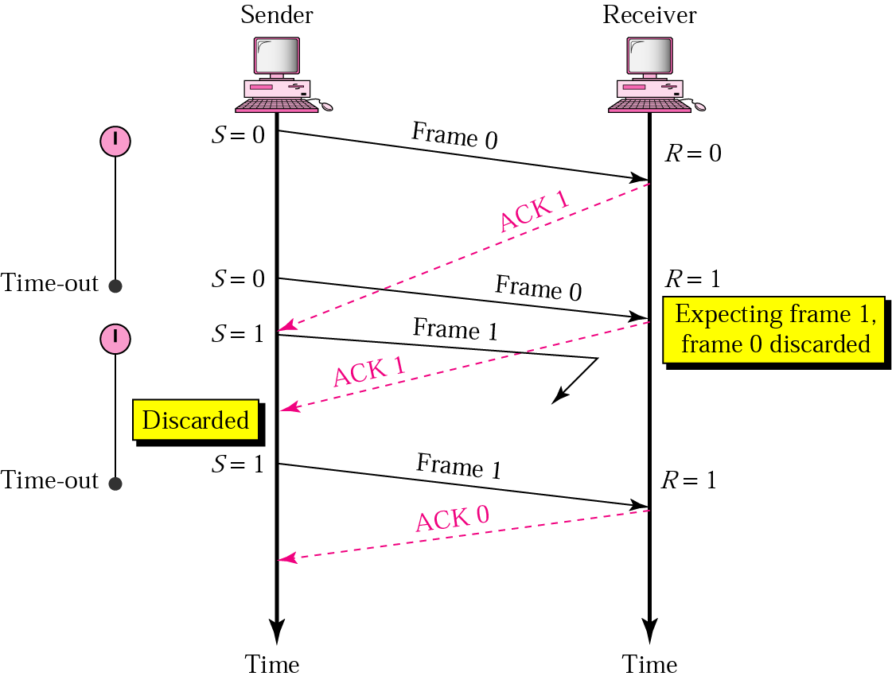

* Figure is courtesy of B. Forouzan

1. Describe the term “Bandwidth-Delay Product” and calculate it for a connection that has a bandwidth of 2 Mbit/s, uses frames of the size of 1000 bit and a round trip time of 50ms. What is the usage of the total bandwidth?

## Go-Back-N ARQ / Selective Repeat ARQ

1. What is the maximum window size for a Go-Back-N ARQ and a Selective Repeat ARQ protocol that use 7 bits to represent the sequence number in the header?
2. Assume you have to design a protocol for a link that has a round-trip time of 100 ms. Errors in the transmission on the link are relatively rare. Suggest a frame size and a flow control mechanism for your protocol. What window size would you suggest for you flow control mechanism.
3. Draw a diagram for a Selective Repeat algorithm similar to the diagrams shown in 1a) that demonstrates the behaviour of Selective Repeat and suggest a suitable window size for a link as described in 2a).
4. Describe the changes you would suggest if the link exhibits more errors than in 2c).
5. Three frames, frame 4, 5, and 6, are send from station A to station B. Station B receives frame 5 and 6 but not frame 4. Draw a diagram that demonstrates the behaviour of a Go-Back-N mechanism and a Selective Repeat mechanism and discuss the difference.

3) Assume that station 00001100 will send a 200 byte response using HDLC. Write out the complete frame for HDLC. Where information such as sequence numbers, etc is not given, choose a number and explain your choice.

Sample Exam Question

**(1c)** Assume you have a connection between two stations that are limited in processing power and storage capacity. Suggest a flow control mechanism that would be suitable for this connection, explain the details of this mechanism and justify your choice by contrasting the mechanism against an alternative mechanism.